Calorie Prediction Using Machine Learning and the Atwater Formula: A Comparison of Linear Regression, Decision Tree, and Random Forest

Abstract
Linear Regression predicted calories most accurately from five macronutrient measurements, reaching a test RMSE of 29.67 kcal and an R² of 0.933 on 1,000 unseen records. Food energy is routinely estimated from nutrient labels for dietary monitoring, yet fixed conversion factors cannot adapt to the data at hand. This study trains regression models on a public Kaggle dataset of 5,000 macronutrient records, using protein, carbohydrates, fat, fiber and sugar as predictors and calories (kcal) as the target. Three traditional algorithms, Linear Regression, Decision Tree and Random Forest, were compared under identical conditions: one 80/20 split, one preprocessing pipeline, the same five-fold cross-validation, and RMSE as the primary metric, with MAE and R² as supporting metrics. Hyperparameters were tuned by exhaustive grid search on the training set only. In validation, Linear Regression reached an RMSE of 30.04 ± 0.38 kcal and an R² of 0.936, ahead of the Decision Tree (RMSE 40.99 kcal). On the untouched test set, its MAE was 24.06 kcal, about 5% of the mean calorie value. The outcome is consistent with the near-linear Atwater relationship between macronutrients and food energy. The selected pipeline is served through a Streamlit application that accepts validated nutrient inputs and returns a calorie estimate.
Keywords: calorie prediction, regression, Atwater factors, Random Forest, Streamlit

I. Introduction
This study asks whether a simple, transparent regression model can predict the calories from its macronutrient profile accurately enough for everyday dietary use, and which of three traditional algorithms does it best.

A. Background and Problem
Calorie values are central to dietary monitoring, weight management and nutrition education. Recording them by hand is demanding: logging apps expect every ingredient and portion to be entered, the process is tedious, and visually estimated portion sizes are error-prone [1]. Behind the printed numbers, food energy is conventionally derived by multiplying measured protein, fat and carbohydrate content by energy conversion factors, a scheme rooted in the Atwater system [2]. A technical workshop convened by the Food and Agriculture Organization noted that several analytical methods and several sets of conversion factors coexist, so the same item can be assigned slightly different energy values depending on the choices made [2]. A data-driven model trained on recorded foods can learn the relationship directly from examples and can be reused wherever a nutrient profile is available, but a calorie value is not.

B. Related Work
Most recent calorie-estimation research works from food images. Thames et al. built the Nutrition5k dataset of about 5,000 real cafeteria dishes with weighed ingredients and trained convolutional networks to predict calories and macronutrients from photographs and depth data [1]. Ruede et al. treated macronutrient values as an auxiliary learning signal when regressing calories from recipe images with a multi-task network [3]. These approaches address a harder perception problem, but they depend on deep learning and large image collections.
Traditional regression has been compared to tabular nutrition data as well. Yang trained Linear Regression, Ridge Regression, Decision Tree and Random Forest models on 2,397 food items with 33 nutrients to estimate nutrient density and reported that the linear models were the most accurate while the tree-based models overfit [4]. That work targets nutrient density rather than calories. The present study applies a comparable three-model design to calorie prediction from a small set of macronutrients, under a controlled protocol with identical splits, folds and metrics for every model.

C. Objectives, Significance and Scope
The objective is to compare Linear Regression, a Decision Tree and a Random Forest for predicting calories (kcal) from protein, carbohydrate, fat, fiber and sugar content. This model asks three questions: (1) which model achieves the lowest cross-validated RMSE; (2) whether a more flexible, nonlinear model improves on the linear baseline; and (3) how well the selected model generalizes to unseen records.
The outcome matters to nutrition students, app developers and dietitians who need a lightweight estimator that is fast, explainable and easy to deploy. The scope is limited to one public dataset of 5,000 records, five numeric predictors, and traditional machine learning methods only. The study does not address portion estimation, image input, cooking effects or individual metabolism. The chosen model is deployed in a Streamlit application so that results can be tried interactively.

II. Methods
The study follows a fixed supervised-learning workflow: data documentation, exploratory analysis, preprocessing, a single train-test split, tuning of three algorithms under identical conditions, one final test evaluation, and deployment. The workflow is implemented in five notebooks (exploratory analysis, one notebook per algorithm, and final evaluation) with a fixed random seed of 42.

A. Dataset and Ethics
The study uses the Food Nutrition and Calories Dataset from Kaggle [5]. It contains 5,000 records, each describing one item by its macronutrient content and energy value. It is not clear whether the author uses laboratory-measured or synthetically generated macronutrients, as their description only notes that it is realistic. The data contains no missing values and no duplicate records. They describe items only and hold no personal or sensitive information about people, so no human-subject consent or ethics review was required. The dataset is publicly available under the MIT License [6] and is acknowledged in the references. The original file was kept unmodified, and the cleaned file was saved separately as a processed dataset.

B. Features and Target
Predicting the energy content of a food in kilocalories from its macronutrient profile. Table I below lists the five predictors and the target. The original file also contains a categorical label, calorie_class, which was excluded because it is derived from the target and would cause target leakage.
TABLE I. Variables used
Variable | Role | Unit | Range | Mean
protein_g | Feature | g | 0.0 to 64.3 | 25.08
carbs_g | Feature | g | 0.0 to 120.6 | 49.85
fat_g | Feature | g | 0.0 to 47.4 | 20.11
fiber_g | Feature | g | 0.0 to 25.9 | 8.10
sugar_g | Feature | g | 0.0 to 51.1 | 15.09
calories | Target | kcal | 56 to 975 | 480.46

C. Exploratory Data Analysis Procedure
Exploratory analysis was performed in Python with pandas [7]. It covered dataset dimensions, data types, missing values, duplicates, impossible values such as negatives, and summary statistics. Univariate distributions of all five features and the target were examined with histograms and kernel density estimates. Relationships were assessed with a Pearson correlation matrix and with scatter plots of protein, carbohydrates and fat against calories. Box plots of every feature were used to investigate outliers. Extreme values that were non-negative and physically plausible were treated as legitimate observations rather than errors, so no records were removed. Findings are reported in Section III.

D. Data Preprocessing
Because the dataset had no missing values, duplicates or negative values, no imputation or record removal was needed. Preprocessing consisted of dropping calorie_class and standardizing the five numeric features with StandardScaler. The scaler is placed inside a scikit-learn Pipeline with a ColumnTransformer [8], so it is fitted only on training data and, within cross-validation, only on the training portion of each fold. This prevents information from validation or test records leaking into training. Scaling is not required by tree-based models, but the identical pipeline was kept for all three algorithms so that the comparison is fair. The cleaned dataset (5,000 rows, six columns) was saved separately from the original.

E. Data Split Strategy
The data were divided into 80% training (4,000 records) and 20% testing (1,000 records) by a random split with a fixed seed. Stratification was not applied because the target is continuous, and a chronological split was unnecessary because the records are not time-ordered. All model selection and tuning used only the training set, with the same five-fold cross-validation [9] (shuffled, seed 42) for every algorithm. The test set stayed untouched until the final model was chosen and was evaluated once.

F. Algorithms
Three distinct, permitted traditional regression algorithms were compared.
- Linear Regression is an interpretable baseline fitted by ordinary least squares. It was chosen because food energy is conventionally computed as a weighted sum of macronutrients using Atwater-type conversion factors [2]. It has no hyperparameters to tune.
- Decision Tree Regressor is based on the CART algorithm [10]. It captures nonlinear thresholds and is easy to interpret.
- Random Forest Regressor [11] averages many decision trees trained on bootstrap samples, which reduces the variance of a single tree and handles nonlinear relationships.
No neural networks, deep learning or AutoML methods were used.

G. Hyperparameter Tuning
Tuning was performed on the training set only, with the same cross-validation folds and RMSE as the scoring metric. Both tree-based models were tuned with an exhaustive grid search (Table II): 135 combinations for the Decision Tree and 54 for the Random Forest. For the Random Forest, max_features takes the values None (all five features), 2 and 3; the options sqrt and log2 were not used because with five features both resolve to two features per split and would test the same setting twice. The selected hyperparameters are reported in Section III.
TABLE II. Hyperparameter search spaces
Model | Search method | Hyperparameters and values
Linear Regression | None | No tuned hyperparameters
Decision Tree | GridSearchCV (135 combinations) | max_depth {3, 5, 7, 10, None}; min_samples_split {2, 5, 10}; min_samples_leaf {1, 2, 4}; max_features {None, sqrt, log2}
Random Forest | GridSearchCV (54 combinations) | n_estimators {100, 200}; max_depth {5, 10, None}; min_samples_leaf {1, 2, 4}; max_features {None, 2, 3}

H. Evaluation Metrics
The primary metric is Root Mean Squared Error (RMSE). It is expressed in kcal, the same unit as the target, and penalizes large errors more heavily, which matters because a large calorie misestimate is more harmful to dietary tracking than several small ones. Supporting metrics are Mean Absolute Error (MAE) and the coefficient of determination (R²):
RMSE = √[(1/n) Σ (yᵢ − ŷᵢ)²]
MAE = (1/n) Σ |yᵢ − ŷᵢ|
R² = 1 − Σ(yᵢ − ŷᵢ)² / Σ(yᵢ − ȳ)²

All three metrics are reported as mean ± standard deviation across the five validation folds for every model. The best model was then evaluated once on the test set, and validation and test results are reported separately. Residual plots and an error distribution of the selected model complete the error analysis. Experiments used Python 3.11 and scikit-learn [8] 1.9.1.

I. Model Deployment
The selected preprocessing and model pipeline was saved as a single file with joblib and loaded by a Streamlit application [12]. The application restricts each field to a valid range (for example, 0 to 300 g of carbohydrates), requires at least one non-zero macronutrient, rejects negative values, and reverts blank or non-numeric entries to default values so it does not crash.

III. Results
Linear Regression had the lowest validation RMSE (30.04 kcal) and the lowest fold-to-fold variability of the three models, and it kept that accuracy on the unseen test set (29.67 kcal).

A. Exploratory Data Analysis Findings
The data are clean. All 5,000 records have seven fields, with no missing values, no duplicates and no negative values (every minimum is zero or above), so no records were removed or imputed.
The five nutrient features and the target are roughly bell-shaped (Fig. 1). Carbohydrates, fiber and sugar have a mild right tail. Every feature also shows a spike at zero, most clearly for sugar, where roughly 430 records fall in the lowest histogram bin. Zero is a plausible value for items with no sugar or fiber, so these records were kept. The target spans 56 to 975 kcal with a mean near 480 kcal and no heavy skew, so no target transformation was applied.
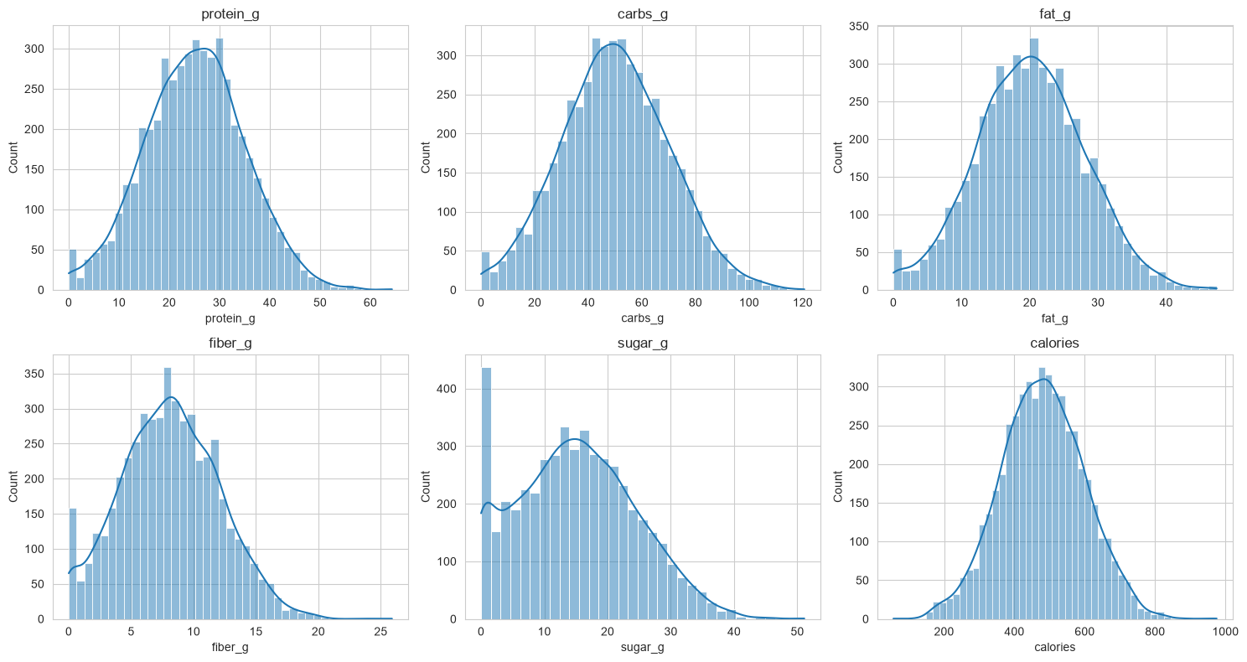
Fig. 1. Histograms with kernel density estimates for the five nutrient features and calories.
Calories correlate most with carbohydrates (r = 0.68), then fat (r = 0.59) and protein (r = 0.33), while fiber and sugar are almost uncorrelated with calories (r ≈ 0.01) (Fig. 2). The five features are nearly uncorrelated with one another (|r| ≤ 0.04), so multicollinearity is not a concern. Scatter plots (Fig. 3) show an approximately linear, upward trend of calories with carbohydrates and with fat, a weaker trend with protein, and visible vertical scatter around each trend. Box plots (Fig. 4) show extreme points only in the upper tail of every feature, with the lower end bounded at zero. The largest values (carbohydrates 120.6 g, fat 47.4 g, protein 64.3 g) are plausible for energy-dense foods, so they were treated as legitimate extremes and retained.
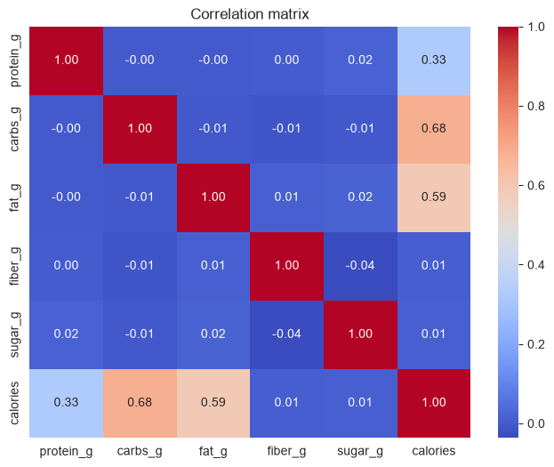
Fig. 2. Pearson correlation matrix of the five features and calories.
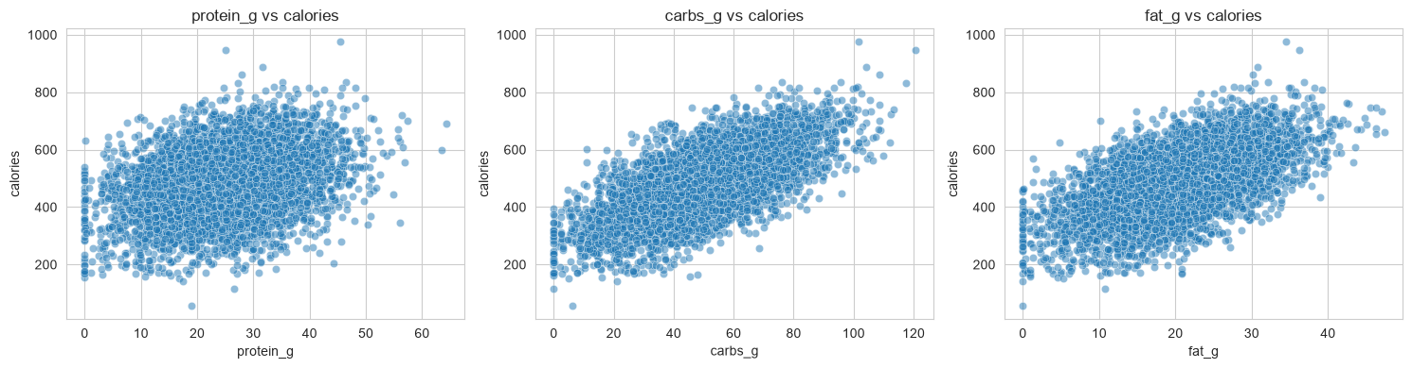
Fig. 3. Calories plotted against protein, carbohydrates and fat.
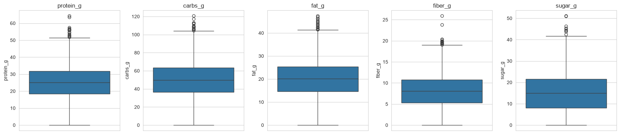
Fig. 4. Box plots of the five nutrient features, used to inspect outliers.
TABLE III. EDA findings and the decisions they led to
Finding | Decision
No missing values, duplicates or negatives | No imputation or record removal
Target approximately bell-shaped, no heavy skew | No transformation; continuous target, so no stratified split; RMSE as primary metric
Calories rise roughly linearly with carbohydrates, fat and protein | Include Linear Regression as a baseline and expected strong candidate
Fiber and sugar nearly uncorrelated with calories | Keep all five features and let each model weigh them; no manual feature removal
Features nearly uncorrelated with each other | No multicollinearity handling needed
Upper-tail extremes within plausible nutrient ranges | Keep; features are standardized inside the shared pipeline
Spike of zeros in each feature | Keep; zero is a valid nutrient amount

B. Validation Results
Table IV compares the three tuned models on the same training data, folds and metrics. Linear Regression has the lowest RMSE and MAE and the highest R², and its fold-to-fold standard deviation of RMSE (0.38 kcal) is the smallest. The tuned Decision Tree used max_depth = 10, max_features = None, min_samples_leaf = 4 and min_samples_split = 10. The tuned Random Forest used n_estimators = 200, max_depth = 10, max_features = 3 and min_samples_leaf = 2.
TABLE IV. Five-fold cross-validation results on the training set (mean ± SD)
Model | RMSE (kcal) | MAE (kcal) | R²
Linear Regression | 30.04 ± 0.38 | 23.91 ± 0.41 | 0.9357 ± 0.0026
Decision Tree | 40.99 ± 0.69 | 32.40 ± 0.50 | 0.8804 ± 0.0038
Random Forest | 33.41 ± 0.85 | 26.33 ± 0.59 | 0.9205 ± 0.0037

C. Final Test Results
Linear Regression was selected because it had the lowest validation RMSE, the smallest variability, the simplest structure and a minimal computational cost. It was then evaluated once on the 1,000 unseen test records (Table V). Test and validation results agree closely: RMSE differs by 0.37 kcal and R² by 0.002, which indicates that the model generalizes and was not overfitted to the training folds. The test MAE of 24.06 kcal is about 5.0% of the mean calorie value of 480.46 kcal, and the test RMSE is about 6.2% of it. For reference, predicting the mean for every record would give an RMSE close to the standard deviation of the target (117.9 kcal), so the model's RMSE is roughly one quarter of that.
TABLE V. Final test results of the selected model (Linear Regression)
Metric | Validation (5-fold mean) | Test (1,000 records)
RMSE (kcal) | 30.04 | 29.67
MAE (kcal) | 23.91 | 24.06
R² | 0.9357 | 0.9334

D. Residual and Erƒror Analysis
Fig. 5. Residual analysis of the Linear Regression model on the test set: predicted versus actual calories (left), residuals versus predicted calories (center), and distribution of residuals (right)
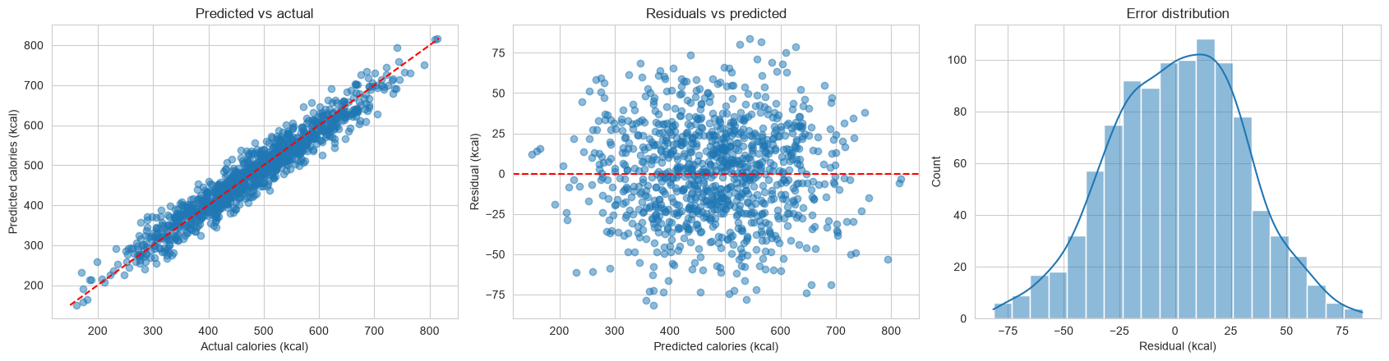In Fig. 5, residual analysis shows near-zero bias (mean = 0.98 kcal) with normally distributed errors (std = 29.67 kcal), though the largest absolute error reaches 83.99 kcal.

E. Application Evidence
The deployed application is available at https://atmxcjmrgtxo2rv8zdwk6w.streamlit.app/ and runs locally from the submitted requirements file. It loads the saved pipeline, so the deployed model, the local model and the model reported in this paper are the same. Table VI lists the input tests and observed results; a sample output is shown in Fig. 6 (Appendix B).
TABLE VI. Application input tests
Case | Input | Expected behavior | Observed
Valid | Typical values for all five nutrients | Calorie estimate in kcal with the model name | The application works as intended.
Boundary, low | All five macronutrients at 0 g | Rejected, with a clear error message | The application will ask to enter at least ONE non-zero macronutrient to function.
Boundary, high | Maximum observed values (Table I) | Accepted; estimate shown | The application accepted the maximum observed values and returned an estimate.
Out of range | Carbohydrates of 500 g | Rejected with a message giving the allowed range | The application allows only 0 – 300g of carbohydrates and halts the predictor.
Invalid | Negative protein | Rejected with a clear error message | The application does not accept negative inputs for the model to use
Missing or text | Blank field or non-numeric text | Rejected, the field reverts to its previous or default value. | The application defaults to constant values to not crash application.

IV. Discussion
Linear Regression won because the calorie value in this dataset behaves like a weighted sum of macronutrients, and a model with that exact form needs no extra flexibility.

A. Why Linear Regression Performed Best
Three pieces of evidence point the same way. First, food energy is conventionally computed by multiplying protein, fat and carbohydrate by conversion factors [2], which is a linear rule, and the EDA showed approximately linear trends of calories with carbohydrates and fat (Fig. 3). Second, the five features are almost uncorrelated with each other, so a linear model can attribute calories to each nutrient without confusion. Third, a simple check on the five sample records in Appendix B shows that applying the common general factors of 4, 4 and 9 kcal/g to protein, carbohydrate and fat lands within about 6% of the recorded calories for every record.
Tree-based models have to approximate a straight-line relationship with steps. The single Decision Tree did so worst (validation RMSE 40.99 kcal), because each leaf averages a small group of records and is therefore sensitive to noise. The Random Forest reduces that variance by averaging many trees and improved on the single tree, but in the results reported here it stayed behind Linear Regression (validation RMSE 33.41 kcal versus 30.04 kcal). This ordering matches the pattern reported by Yang, where linear models led and tree-based models overfit on tabular nutrition data [4], although that study predicted nutrient density rather than calories.
The ranking does not depend on the metric. Linear Regression is best on RMSE, MAE and R² alike, and its fold-to-fold variability is the smallest, so the choice is stable rather than the result of one favorable metric or fold.

B. Errors and Practical Meaning
On unseen data the model is off by about 24 kcal on average (MAE), roughly 5% of a typical 480 kcal item. That suits meal-level tracking, menu planning and teaching, but not uses that need label-grade precision. Because the more flexible models did not reduce the error, the remaining error looks like noise relative to these five predictors rather than a missed nonlinearity. Likely sources are factors absent from the data, such as alcohol or water content, and rounding or measurement variation in the records. Residual analysis shows near-zero bias (mean = 0.98 kcal) with normally distributed errors (std = 29.67 kcal), though the largest absolute error reaches 83.99 kcal.

C. Tradeoffs
Linear Regression is the most interpretable option, since each coefficient states how many kilocalories one standardized unit of a nutrient adds, and it is also the cheapest to train and serve in the application. The Decision Tree offers readable thresholds but is unstable. The Random Forest is more robust than a single tree but harder to explain and larger to deploy. A Random Forest would be the better choice if the data contained strong interactions or saturation effects, which the EDA did not reveal here.

D. Caution About the Data
Two patterns in the EDA suggest the dataset may be partly or wholly synthetic. Sugar is normally a component of carbohydrate, yet the two are uncorrelated here (r = -0.01), and every feature shows a spike of exactly zero values that resembles values truncated at zero. If the calorie values were generated from a linear formula plus noise, part of the advantage of Linear Regression would be built into the data, and the ranking might differ on measured food-composition data. This should be settled by checking how the dataset was produced and is listed as a limitation in Section V.

V. Conclusion and Recommendations
Linear Regression is the best of the three traditional models for predicting calories from five macronutrient values, with a validation RMSE of 30.04 ± 0.38 kcal and a test RMSE of 29.67 kcal, MAE of 24.06 kcal and R² of 0.933. It outperformed the tuned Decision Tree (validation RMSE 40.99 kcal) and the tuned Random Forest, was the most stable across folds, and generalized to the 1,000 unseen records without loss of accuracy. This answers the research objective: a simple, interpretable linear pipeline is accurate enough for everyday dietary estimation, and added model flexibility did not help. The pipeline is deployed in a Streamlit application that validates inputs and returns a calorie estimate with the model name, giving students and app developers a quick way to estimate energy from a nutrient profile.
The study has limits. It uses one public dataset of 5,000 records whose origin may be synthetic (Section IV-D), so the ranking of models may not carry over to measured food-composition data. The model uses five nutrients only and ignores portion size, preparation method, alcohol and water content. Only three algorithms were compared, with a single random split and no external test set.
Realistic next steps are:
- Verify how the dataset was produced and repeat the comparison on an independent dataset with verified composition values, such as one derived from a national food-composition database as in [1].
- Add predictors that affect energy, such as water or alcohol content and serving size, and test regularized linear models (Ridge or Lasso) and Gradient Boosting under the same protocol.
- Report prediction intervals in the application so that users see the expected error range, not only a single number.
- Use the dataset's calorie class label for a companion classification study if a low, medium or high category is more useful than an exact value.

References
[1] Q. Thames et al., "Nutrition5k: Towards automatic nutritional understanding of generic food," arXiv:2103.03375, 2021. [Online]. Available: https://arxiv.org/pdf/2103.03375
[2] Food and Agriculture Organization of the United Nations, "Food energy: Methods of analysis and conversion factors," FAO Food and Nutrition Paper 77, Report of a Technical Workshop, Rome, Italy, Dec. 3-6, 2002. Rome, Italy: FAO, 2003. [Online]. Available: https://www.fao.org/3/Y5022E/Y5022E00.htm
[3] R. Ruede, V. Heusser, L. Frank, A. Roitberg, M. Haurilet, and R. Stiefelhagen, "Multi-task learning for calorie prediction on a novel large-scale recipe dataset enriched with nutritional information," arXiv:2011.01082, 2020. [Online]. Available: https://arxiv.org/pdf/2011.01082
[4] C. Yang, "Predicting nutrient density in foods using machine learning models: A comparative study," in Proc. 2nd Int. Conf. Data Analysis and Machine Learning (DAML), SciTePress, 2024, pp. 64-69, doi: 10.5220/0013487500004619.
[5] amineipad, "Food Nutrition and Calories Dataset," Kaggle, 2026. [Online]. Available: https://www.kaggle.com/datasets/amineipad/food-nutrition-dataset-for-calorie-classification (Accessed Oct. 14, 2026).
[6] Open Source Initiative, “The MIT License,” opensource.org, 2026. [Online]. Available: https://opensource.org/license/mit(Accessed Oct. 14, 2026).
[7] W. McKinney, "Data structures for statistical computing in Python," in Proc. 9th Python in Science Conf. (SciPy), 2010, pp. 56-61.
[8] F. Pedregosa et al., "Scikit-learn: Machine learning in Python," J. Mach. Learn. Res., vol. 12, pp. 2825-2830, 2011.
[9] R. Kohavi, "A study of cross-validation and bootstrap for accuracy estimation and model selection," in Proc. 14th Int. Joint Conf. Artificial Intelligence (IJCAI), 1995, pp. 1137-1143.
[10] L. Breiman, J. H. Friedman, R. A. Olshen, and C. J. Stone, Classification and Regression Trees. Belmont, CA, USA: Wadsworth, 1984.
[11] L. Breiman, "Random forests," Mach. Learn., vol. 45, no. 1, pp. 5-32, 2001.
[12] Streamlit Inc., "Streamlit documentation," 2026. [Online]. Available: https://docs.streamlit.io. (Accessed Oct. 14, 2026).

Appendices

Appendix A. Data Dictionary
Variable | Description | Type | Unit | Observed range | Use
protein_g | Protein content | float | g | 0.0 to 64.3 | Feature
carbs_g | Carbohydrate content | float | g | 0.0 to 120.6 | Feature
fat_g | Fat content | float | g | 0.0 to 47.4 | Feature
fiber_g | Dietary fiber content | float | g | 0.0 to 25.9 | Feature
sugar_g | Sugar content | float | g | 0.0 to 51.1 | Feature
calories | Energy value | float | kcal | 56 to 975 | Target
calorie_class | Categorical calorie label (for example low or medium), derived from calories | text | none | not applicable | Excluded (target leakage)

Appendix B. Sample Records, Atwater Check, and Application Outputs
The table shows the first five records of the dataset. The Atwater estimate applies 4 kcal/g to protein and carbohydrate and 9 kcal/g to fat.
Record | Protein (g) | Carbs (g) | Fat (g) | Fiber (g) | Sugar (g) | Recorded kcal | Atwater estimate (kcal) | Estimate vs recorded
0 | 22.5 | 65.2 | 13.7 | 9.9 | 26.7 | 479 | 474.1 | -1.0%
1 | 15.9 | 20.7 | 16.8 | 7.6 | 15.0 | 316 | 297.6 | -5.8%
2 | 28.3 | 62.4 | 14.5 | 10.8 | 15.3 | 524 | 493.3 | -5.9%
3 | 23.3 | 18.6 | 7.9 | 17.0 | 0.2 | 250 | 238.7 | -4.5%
4 | 30.8 | 55.1 | 31.9 | 12.5 | 7.2 | 602 | 630.7 | +4.8%
Fig. 6. Sample input & output from deployed Streamlit application


Appendix C. Group Contribution Record
Member | Assigned responsibility | Actual contribution | Confirmed by member
Millonte, Lord Cedrick M. | Coder, Researcher | Mostly helped clean up and separate the algorithm files, redid the readme and wrote most of the paper
Manalang, Wil Conrad | Coder, Researcher | Wrote the algorithms, LR, DT, RF. Also made the streamlit website after Luna initially made
Luna, Robi Troy | Coder, Researcher | Made the EDA & Streamlit website
Cadiz, Jefferson de | Coder, Researcher | Handled data preprocessing, supported & helped Wil & Robi write the initial code

Appendix D. Ownership and Authorship Declaration
Project title: Calorie Prediction Using Machine Learning and the Atwater Formula. Course and section: 241 – Machine Learning. Group name: TheBoys. Date submitted: 10/15/2026.
The signed declaration, completed from the course template and signed by Dr. Armida P. Salazar and every group member, is attached here as a PDF and stored in the documentation folder.
Name and role | Signature | Date
Dr. Armida P. Salazar, Course Instructor
Millonte, Lord Cedrick M.
Manalang, Wil Conrad
Luna, Robi Troy
De Cadiz, Donn Jefferson

